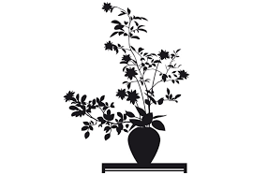
CRAFT TASTER DAY
SATURDAY 7TH OCTOBER 2017 10am to 4pm

at the Simpson Hall, Burghill (4 miles north west of Hereford)
Cost £20 for the day *

Because there is no August County News, this flier and application form are going out rather early – but don’t leave it too late to book to get the group of your choice. We hope to get more details of the activities and some pictures onto the HFWI website soon. Details of equipment needed will be sent to those taking part nearer the time.

There will be four craft activities on offer and you will need to opt for ONE of them. They are

Flower Arranging with Noella Plasman-Jones: ‘East Meets West’
Noella will demonstrate different flower arranging traditions, including some Ikebana, and then there will be the chance for you to have a go.

Make a Paperback Hedgehog with Mary Roberts.
You will have seen how old books can be made into attractive sculptural objects. Mary will show you how to turn an old paperback into a hedgehog as well as other paper-folding ideas

Christmas Home and Garden with Jenny Winchester.
Jenny will show you how to make something to decorate your Christmas table and also a bird feeder for the winter garden.

Make a small woven tapestry with Joanna Helme
Using an old picture frame as a ‘loom’, Joanna will show you how you can use all kinds of yarn to give colour and texture in making a small weaving using a darning needle.

Tea and coffee will be available throughout the day. Please bring something for a Bring and Share Lunch.
*There may be a small charge for some materials

