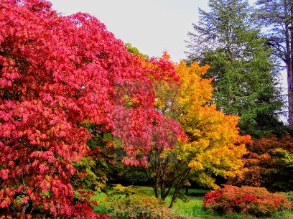 | AUTUMN COLOURS AT WESTONBIRT – THE NATIONAL ARBORETUM  SATURDAY 28th OCTOBER 2023
Cost for Coach & Entrance: £36.00 per person + optional guided walk

Time & Pick-up Points: LEOMINSTER 9.00am Broad Street Car Park, Leominster (HR6 8DD) HEREFORD 9.30am Bus Station, Commercial Road, Hereford (HR1 2EP) ROSS-ON-WYE10.00am Wilton Car Park, Ross-on-Wye (HR9 5JA)

Return Time: Leaving Westonbirt at 3.00pm

Details: Westonbirt Arboretum is one of the most beautiful and important plant collections in the world. At 600 acres and with 15,000 specimens, and 2,500 species of tree from all over the world, the arboretum plays a vital part in research and conservation, as well as being a stunningly beautiful place to visit and explore rare, interesting and beautiful plants from the furthest corners of the globe. There is the option of a guided walk for up to 1.5hrs and at a cost of £2.50. Mobility scooters or wheelchairs are available if requested in advance (see booking form). There is a restaurant and take-away café on site, but equally you can bring your own.

The trip will be open to EVERYONE, so do bring a friend.

Closing date: Friday, 29th September 2023

Please retain this part of the form for your information and return the cut-off portion below with ALL the details we require to make the booking – Thank you. Direct any questions to: admin@herefordshirewi.org.uk or 01432 272268

&----------------------------------------------------------------------------------------------------------------------------------
Return with payment to: Caroline Miller, Asst Fed Secretary, WI House, 90 St Owen Street, Hereford, HR1 2QD
by Friday 29th September 2023. admin@herefordshirewi.org.uk or 01432 272268

AUTUMN COLOURS AT WESTONBIRT – THE NATIONAL ARBORETUM - SATURDAY 28th OCTOBER 2023
Name of WI: ………………………………………………………………………………………………….

Contact Name: ……………………………………………………… Telephone No: ……………………………………………..

PAYMENT: * delete as appropriate
*One WI BACS payment quoting HFWI Reference: HFWIWestonbirt281023 to
Herefordshire Federation of Women’s Institutes Sort Code: 30 65 22 Account No 76843268
OR
*Enclosed cheque (preferably a WI cheque). Made payable to HFWI. All payments must be accompanied by the HFWI ref no (see top right of this page) on back of cheque.

** IMPORTANT – Please quote HFWI Reference with ANY payment and note that receipts will only be issued for cash payments.

PLEASE COMPLETE THE ATTENDEE DETAILS ON THE REVERSE OF THIS FORM

&----------------------------------------------------------------------------------------------------------------------------------
Return with payment to: Caroline Miller, Asst Fed Secretary, WI House, 90 St Owen Street, Hereford, HR1 2QD
by Friday 29 September 2023. admin@herefordshirewi.org.uk or 01432 272268

ATTENDEE DETAILS FOR AUTUMN COLOURS AT WESTONBIRT - SATURDAY 28th OCTOBER 2023
IMPORTANT, for health and safety reasons in case of an emergency on the trip: Please provide the following details:
Name of Attendee | Attendee’s  Mobile No | Emergency Contact  Name | Emergency Contact  Tel. No. | Pick-up Point  LEOM/HFD/ROSS | Tour  Yes/No | Mobility  Assistance  Yes/No
Please continue on separate sheet, if necessary

