**HFWI 2026 CALENDAR COMPETITION**

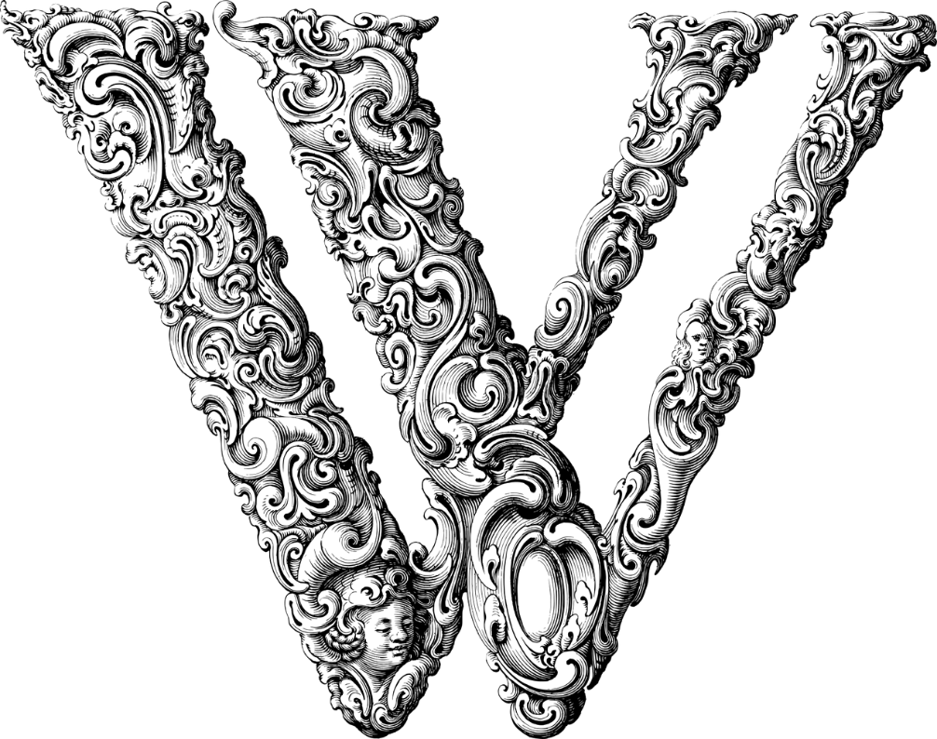

The letter **W**

You may question if we have lost the plot, but, think about it, how many things can you find relating to or starting with the letter **W**?

Wellingtons, wet, wheat, WI, winter, wildlife, windows, woodpiles, wreaths, wrapping paper, the list is endless. The calendar must obviously cover the entire twelve months so when creating your picture think about the month as well as the composition.

We are sure you will be inspired by the theme and will get your phones/cameras out for another successful competition, have fun and let your imagination run wild.

There is a cash prize plus the award of the Calendar Cup for the winning photograph, which will go on the front cover of the calendar.

Photographs must be:

* in a digital format, of a minimum 300 dpi, taken in a landscape format, **NOT** portrait. Please do not send images from an office printer as they pixelate. We will not accept any other format. Remember to turn the date function off.

Closing Date: **31st JANUARY 2025**

Send your entries clearly marked ‘Calendar 2026’ to Caroline Wright, Federation Secretary, at fedsec@herefordshirewi.org.uk, together with:

* Your name, your WI, title of picture and month when taken plus a short description of the subject, what attracted you to it and what we are seeing (maximum of 30 words).

Our calendars are also given as presents and some posted out all over the world, what a lovely way to showcase our county and photographers.

Good luck.