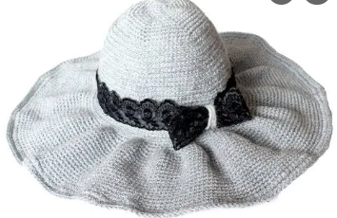 | 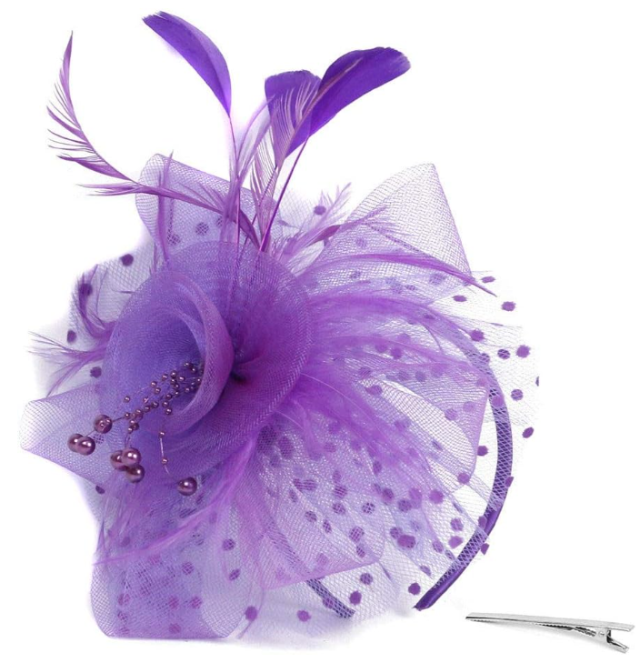 | 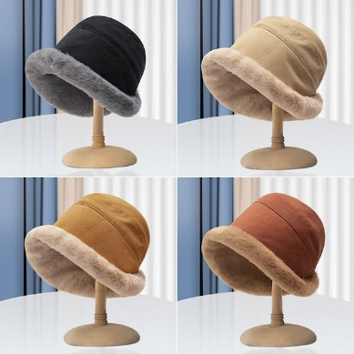
THE EIRA FURLONG CUP
HFWI HANDICRAFT COMPETITION
2024

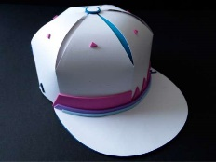 | 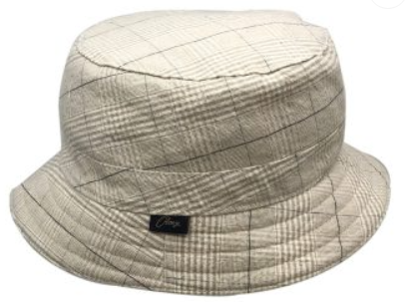 | 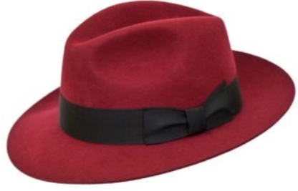
The Federation is pleased to announce the 2024 Handicraft Competition for the Eira Furlong Cup.

Competitors are asked to make:

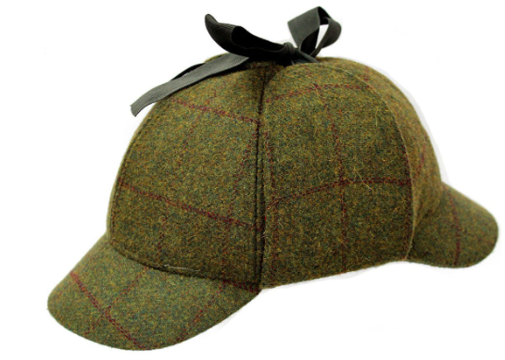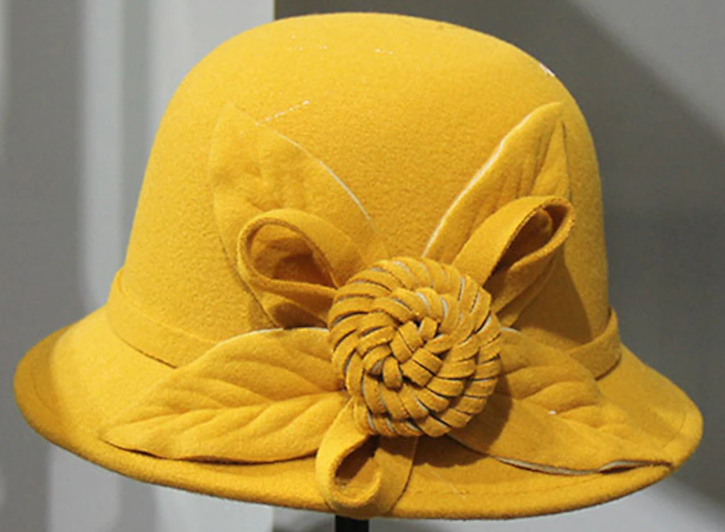  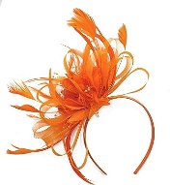 | - A Hat or Fascinator  - Any medium  - Any size  - Any Type  - The entire item to be made by the competitor except for a comb or band in a fascinator.  - Must be wearable. |  | 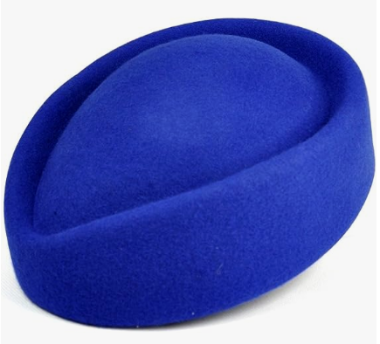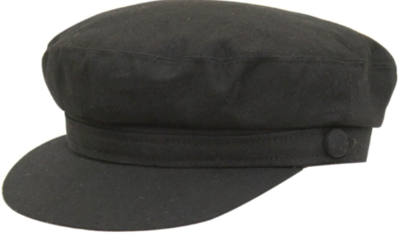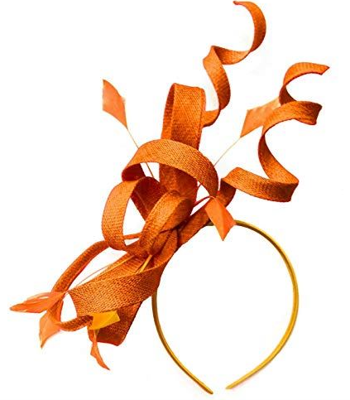

Please attached your name, institute and contact details to your entry and send or bring it to WI House by 31st July 2024.

Entries will be displayed on WI Day, Saturday 14th September 2024 at Credenhill Community Hall, HR4 7EB and at HFWI’s Annual Council Meeting 2024. Your entry can be collected after the ACM or from WI House.

For further details contact chair@herefordshirewi.org.uk or 01885 400700
Closing Date: 31ST JULY 2024

